|  |  |  |  |  |  |  |
| --- | --- | --- | --- | --- | --- | --- |
| |  |  |  |  | | --- | --- | --- | --- | |  | | **MINISTRY OF EDUCATION AND TRAINING** | | | **FPT UNIVERSITY** | | |
| Capstone Project Document |
| Online Medical Consultant System |
| |  |  |  |  |  |  |  |  |  |  |  | | --- | --- | --- | --- | --- | --- | --- | --- | --- | --- | --- | | |  |  | | --- | --- | | **Group 02 – Report 03** | | | **Group member** | Trần Nguyên Tiến Sứ - Team Leader - SE60781  Trần Cao Danh - Team Member - SE60705 | | **Supervisor** | Mr. Nguyễn Huy Hùng | | **Ext. Supervisor** | N/A | | **Capstone Project code** | OMCS | | |
| * Ho Chi Minh City, 11 May / 2014 – |

Table of Contents

List of Tables 3

List of Figures 4

Definitions, Acronyms, and Abbreviations 4

Part B. Report 3: System Requirements Specifications (SRS) 5

1. User Requirement Specification 5

1.1. Guest Requirement 5

1.2. User Requirement 5

1.3. Patient Requirement 5

1.4. Doctor Requirement 5

1.5. Admin Requirement 6

2. System Requirement Specification 6

2.1. External Interface Requirements 6

2.2. Functional Requirements 7

# List of Tables

Table 1 <Guest> Login 11

Table 2 <Guest> Register 12

Table 3 <Doctor><Admin> View Medical Profile 13

Table 4 <Doctor><Patient> Chat 14

Table 5 <Doctor><Patient> Request Webcam 15

Table 6 < Patient> Show webcam 16

Table 7 <Doctor>< Patient> Upload Attachment 18

Table 8 < Patient> View consult history 19

Table 9 < Patient> View doctor online 20

Table 10<Doctor>< Admin> Update medical profile 21

Table 11 <Admin> Create doctor 23

Table 12 <Admin> Edit doctor 24

Table 13<Admin> Search doctor 25

Table 14 <Admin> Deactivate Doctor 26

Table 15 <Admin> Activate doctor 28

Table 16 <Admin><Doctor> Create patient 29

Table 17 <Admin><Doctor> Edit patient 30

Table 18 <Admin><Doctor> Search patient 32

Table 19 <Admin> Deactivate patient 33

Table 20 <Admin> Activate patient 34

Table 21 <Admin> Update medical profile template 35

Table 22 <Admin><Doctor><Patient> Change picture profile 36

Table 23 <Admin><Doctor><Patient> Change password 38

Table 24 <Admin> Define new medical profile template 39

Table 25 <Admin><Doctor><Patient> Logout 41

# List of Figures

Figure 1 System Use Case Overview 6

Figure 2 <Admin> Use Case Overview 7

Figure 3 <Guest> Login 10

Figure 4 <Guest> Register 11

Figure 5 <Doctor><Patient> View Medical Profile 12

Figure 6 <Doctor><Patient> Chat 13

Figure 7 <Doctor><Patient> Request Webcam 14

Figure 8 < Patient> Show webcam 16

Figure 9 <Doctor>< Patient> Upload Attachment 17

Figure 10< Patient> View consult history 18

Figure 11 < Patient> View doctor online 19

Figure 12 <Doctor>< Admin> Update medical profile 20

Figure 13 <Admin> Create doctor 22

Figure 14<Admin> Edit doctor 23

Figure 15 <Admin> Search doctor 24

Figure 16 <Admin> Deactivate Doctor 25

Figure 17 <Admin> Activate doctor 27

Figure 18 <Admin><Doctor> Create patient 28

Figure 19 <Admin><Doctor> Edit patient 29

Figure 20 <Admin><Doctor> Search patient 30

Figure 21 <Admin> Deactivate patient 32

Figure 22 <Admin> Activate patient 33

Figure 23 <Admin> Update medical profile template 34

Figure 24<Admin><Doctor><Patient> Change picture profile 35

Figure 25 <Admin><Doctor><Patient> Change password 37

Figure 26 <Admin> Define new medical profile template 38

Figure 27 <Admin><Doctor><Patient> Logout 40

# Definitions, Acronyms, and Abbreviations

# Report 3: System Requirements Specifications (SRS)

## User Requirement Specification

**OMCS** is a website that provides the convenient way by let patient communicate face-to-face with health care provider via social media. It helps improving the processes of medical treatment.

### Guest Requirement

To satisfy the demand of guest, system has these functions:

* **Registration**: guest need to register to become member. Username, password, email are required for registration.
* **Login**: guest can logged in with email and password.

### User Requirement

After login successful, user have these functions:

* **Update profile**: user have the ability to manage their profile information. He can update some basic information (name, email, birthday, address,…) or change profile picture.
* **Change password**: user can change their password.

### Patient Requirement

If user login with role patient, he can have these functions:

* **Update personal health record:** patient has their own personal health record (height, weight, life styles,…) and he can update it.
* **View medical profile:** patient have ability to view their medical profile.
* **View doctor online:** patient can see doctor online status.
* **Chatting:** patient can choose doctor and send message to get consulted.
* **Upload attachment:** patient can upload files and send to doctor.
* **Show webcam:** patient can share their webcam for doctor.
* **Comment doctor:** patient can post comment about doctor.
* **Rating doctor:** patient can rate doctor.

### Doctor Requirement

If user login with role doctor, he can have these functions:

* **Manage patient:** doctor can create account for patient, update patient information, search patient
* **Update medical profile:** doctor can create medical profile for patient and update information.
* **View medical profile:** doctor can view medical profile of a patient.
* **Chatting:** doctor can reply message from patient
* **Upload attachment:** doctor can upload files and send to patient.
* **Request webcam:** doctor can request patient to share their webcam.
* **View comment/rating:** doctor can view comments from patients with average rating point.
* **Reply comment:** doctor have ability to reply comment from patients.

### Admin Requirement

If user login with role admin, he can have these functions:

* **Manage doctor:** admin can create, edit, active/de-active doctor account, search doctor.
* **Manage patient:** admin can create, edit, active/de-active patient account, search patient.
* **Define new medical profile template**
* **Update existing medical profile template**
* **Manage comment:** admin can review, delete comments.

## System Requirement Specification

### Functional Requirements

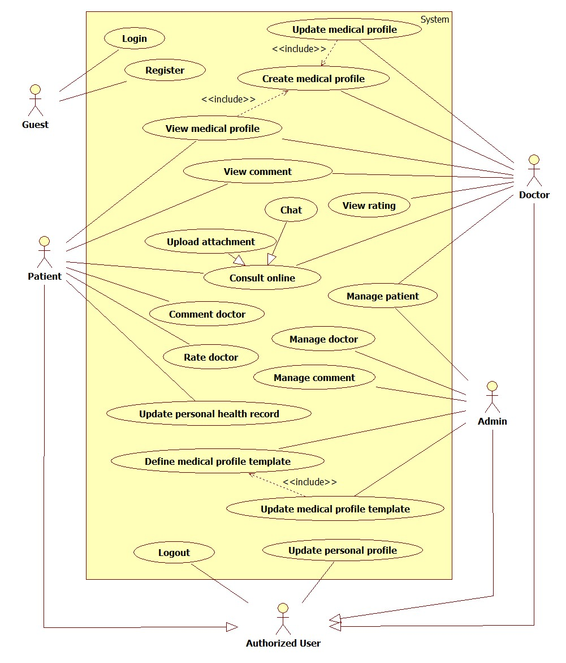

Figure 1 System Use Case Overview



Figure 2 <Guest> Use Case Overview

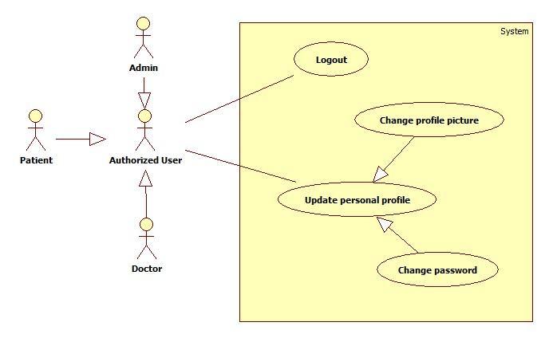

Figure 3 <Authorized User> Use Case Overview

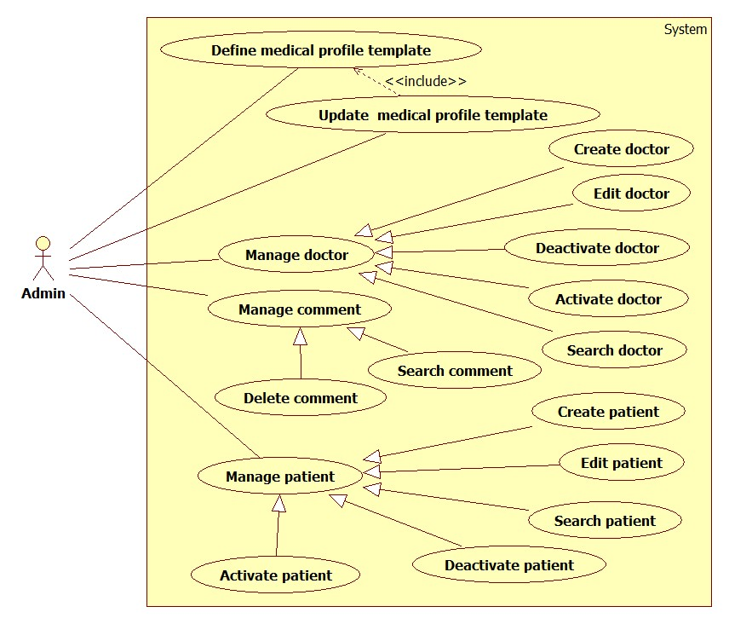

Figure <Admin> Use Case Overview

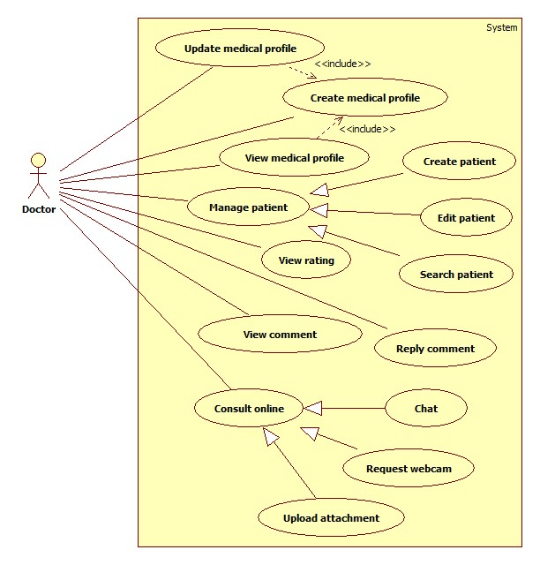

Figure 5 <Doctor> Use Case Overview

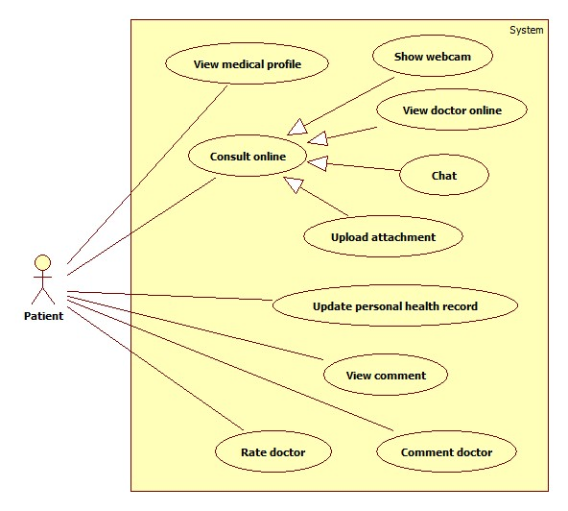

Figure <Patient> Use Case Overview

#### Functional Requirement 1 - Login

#### Use Case-1 Diagram

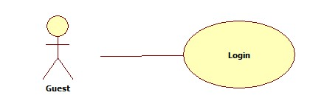

Figure 7 <Guest> Login

#### Use Case-1 Specification

|  |  |  |  |  |
| --- | --- | --- | --- | --- |
| **USE CASE - 1 SPECIFICATION** | | | | |
| **Use-case No.** | UC_001 | **Use-case Version** | | **1.0** |
| **Use-case Name** | <Guest> Login | | | |
| **Author** | SuTNT | | | |
| **Date** | 29/05/2014 | **Priority** | Normal | |
| **Actor:**   * Guest   **Summary:** Logging into system  **Goal:** Check user’s role to use system’s functions.  **Triggers:**Click on “Đăng nhập” link to log in  **Preconditions:**   * Page is loaded successfully. * Users are in “Login” page.   **Post-Conditions:**   * Success: member login successfully. * Failure: System displays error message. Content of error message will specify in Exception section.   **Main Success Scenario:**   |  |  |  | | --- | --- | --- | | Step | Actor Action | System Response | | 1 | Click “Đăng nhập” link on “Trang Chủ” page. | * Redirect to “Login” page. * Display form to input login information: * Email [input] * Mật khẩu [input] * Đăng nhập [button] | | 2 | User input email and password. |  | | 3 | User clicks on “Đăng nhập” button. | * Validate email and password. * Redirect to page follow user’s role. |   **Alternative Scenario:** N/A  **Exception:**   |  |  |  | | --- | --- | --- | | No | Actor Action | System Response | | 1 | When user fills wrong email or password. | Display a hint message “Email hoặc mật khẩu không đúng ". | | 2 | Email or password is blank. | Show message: “Vui lòng điền vào trường này”. | | 3 | Internet connection has problem | Display message “Kết nối mạng bị lỗi. Xin thử lại” |   **Relationship:** N/A  **Business Rules:**   * Each patient, doctor, admin has an account. * Only active account can log in. | | | | |

Table 1 <Guest> Login

#### Functional Requirement 2 - Register

#### Use Case-2 Diagram

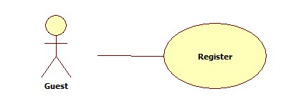

Figure 8 <Guest> Register

#### Use Case-2 Specification

|  |  |  |  |  |
| --- | --- | --- | --- | --- |
| **USE CASE - 2 SPECIFICATION** | | | | |
| **Use-case No.** | UC_002 | **Use-case Version** | | **1.0** |
| **Use-case Name** | <Guest> Register | | | |
| **Author** | DanhTC | | | |
| **Date** | 29/05/2014 | **Priority** | Normal | |
| **Actor:**   * Guest   **Summary:** User uses this function to register into system.  **Goal:** Help guest to create an account on website.  **Triggers:**Click on “Đăng ký” link to “Register” page.  **Preconditions:**   * Page is loaded successfully * Register page will be shown   **Post-conditions:**   * Guest become member of website   **Main Success Scenario:**   |  |  |  | | --- | --- | --- | | Step | Actor Action | System Response | | 1 | User clicks on “Đăng ký” link on homepage | * Display “Đăng ký” page. * Display a form to input registration information. | | 2 | User fills all mandatory fields. |  | | 3 | User clicks on “Đăng ký” button. | * Validate the inputted information. * Insert into database. |   **Alternative Scenario:** N/A  **Exception:**   |  |  |  | | --- | --- | --- | | No | ActorAction | System Response | | 1 | “Email”, “Họ”, “Tên”, “Mật khẩu”, “Xác nhận mật khẩu” text-box is empty | Display message: “Bạn cần nhập giá trị này”. | | 2 | When user fills email not correct format | Display message “Email không đúng định dạng”. | | 3 | When user fills exist email | Display message “Địa chỉ email đã tồn tại”. | | 4 | Mandatory field which have a mark ”*” is empty | Display message “Bạn cần nhập giá trị này”. | | 5 | When user fills password is more than 32 characters or less than 6 characters | Display message “Độ dài trong khoảng từ 6 đến 32 kí tự”. | | 6 | When user fills re-password not match password | Display message “Xác nhập mật khẩu không trùng khớp”. | | 7 | Captcha is empty | “Mã captcha không được để trống”. | | 8 | Captcha not match captcha picture | “Mã captcha không trùng khớp”. |   **Relationship:** N/A  **Business Rules:**   * Each created account must be inactive and has role “patient”. * Each created account will be active when users active theirs account through email. | | | | |

Table 2 <Guest> Register

#### Functional Requirement 3 - View Medical Profile

#### Use Case-3 Diagram



Figure 9 <Doctor><Patient> View Medical Profile

#### Use Case-3 Specification

|  |  |  |  |  |
| --- | --- | --- | --- | --- |
| **USE CASE - 3 SPECIFICATION** | | | | |
| **Use-case No.** | UC_003 | **Use-case Version** | | **1.0** |
| **Use-case Name** | <Doctor><Patient> View Medical Profile | | | |
| **Author** | SuTNT | | | |
| **Date** | 29/05/2014 | **Priority** | Normal | |
| **Actor:**   * Patient * Doctor   **Summary:** This use case is about Viewing medical profile for a patient.  **Goal:** View detail of a medical profile.  **Triggers:** Patient clicks on “Xem chi tiết**”** button on “MedicalProfile” page.  **Preconditions:**   * User must log in with role “Patient” or “Doctor”.   **Post-Conditions:**   * Page load successfully.   **Main Success Scenario:**   |  |  |  | | --- | --- | --- | | Step | Actor Action | System Response | | 1 | User clicks on “Xem chi tiết” button. | Redirect into “Detail” page to shows medical profile details. |   **Alternative Scenario:** N/A  **Exception:**   |  |  |  | | --- | --- | --- | | No | Actor Action | System Response | | 1 | Medical profile is broken. | Display message “Hồ sơ bệnh án bị lỗi.” | | 3 | Internet connection has problem | Display message “Kết nối mạng bị lỗi. Xin thử lại” |   **Relationship:** N/A  **Business Rules:** N/A | | | | |

Table 3 <Doctor><Admin> View Medical Profile

#### Functional Requirement 4 – Chat

#### Use Case-4 Diagram



Figure 10 <Doctor><Patient> Chat

#### Use Case-4 Specification

|  |  |  |  |  |
| --- | --- | --- | --- | --- |
| **USE CASE - 4 SPECIFICATION** | | | | |
| **Use-case No.** | UC_004 | **Use-case Version** | | **1.0** |
| **Use-case Name** | <Doctor><Patient> Chat | | | |
| **Author** | DanhTC | | | |
| **Date** | 29/05/2014 | **Priority** | Normal | |
| **Actor:**   * Doctor * Patient   **Summary:** This use case is about chatting between doctor and patient.  **Goal:** User can send message to each other.  **Triggers:**   * Doctor is on “DoctorConversation” page and patient is on “UserConversation” page. * User input to text-box and clicks on “Gửi” button to send message.   **Preconditions:**   * User must log in with role “Doctor” or “Patient”. * User is on chat page.   **Post-Conditions:**   * Success: Send and receive message successfully. * Failure: System displays error message. Content of error message will specify in Exception section.   **Main Success Scenario:**   |  |  |  | | --- | --- | --- | | Step | Actor Action | System Response | | 1 | User inputs message to text-box and clicks on “Gửi” button. | Send message to chat partner and display that message for him/her. |   **Alternative Scenario:** N/A  **Exception:**   |  |  |  | | --- | --- | --- | | No | Actor Action | System Response | | 3 | Internet connection has problem | Display message “Kết nối mạng bị lỗi. Xin thử lại” |   **Relationship:** Consult online  **Business Rules:** N/A | | | | |

Table 4 <Doctor><Patient> Chat

#### Functional Requirement 5 – Request Webcam

#### Use Case-5 Diagram



Figure 11 <Doctor><Patient> Request Webcam

#### Use Case-5 Specification

|  |  |  |  |  |
| --- | --- | --- | --- | --- |
| **USE CASE - 5 SPECIFICATION** | | | | |
| **Use-case No.** | UC_005 | **Use-case Version** | | **1.0** |
| **Use-case Name** | <Doctor> Request Webcam | | | |
| **Author** | SuTNT | | | |
| **Date** | 29/05/2014 | **Priority** | Normal | |
| **Actor:**   * Doctor   **Summary:** This use case is about Requesting webcam when chatting.  **Goal:** Doctor can request showing webcam from patient.  **Triggers:**   * User clicks on “Xem webcam” button on chat page.   **Preconditions:**   * User must log in with role “Doctor”. * User is on chat page.   **Post-Conditions:**   * Success: Send request successfully. * Failure: System displays error message. Content of error message will specify in Exception section.   **Main Success Scenario:**   |  |  |  | | --- | --- | --- | | Step | Actor Action | System Response | | 1 | User clicks on “Xem webcam” button. | Display message “Bạn đã gửi yêu cầu xem webcam bệnh nhân...” on “Doctor” Page. |   **Alternative Scenario:** N/A  **Exception:**   |  |  |  | | --- | --- | --- | | No | Actor Action | System Response | | 3 | Internet connection has problem | Display message “Kết nối mạng bị lỗi. Xin thử lại” |   **Relationship:** Consult online  **Business Rules:**   * User can’t send the next request when patient doesn’t answer. | | | | |

Table 5 <Doctor><Patient> Request Webcam

#### Functional Requirement 6 – Show Webcam

#### Use Case-6 Diagram



Figure 12 < Patient> Show webcam

#### Use Case-6 Specification

|  |  |  |  |  |
| --- | --- | --- | --- | --- |
| **USE CASE - 6 SPECIFICATION** | | | | |
| **Use-case No.** | UC_006 | **Use-case Version** | | **1.0** |
| **Use-case Name** | <Patient> Show Webcam | | | |
| **Author** | DanhTC | | | |
| **Date** | 29/05/2014 | **Priority** | Normal | |
| **Actor:**   * Patient   **Summary:** This use case is about Showing webcam when chatting.  **Goal:** User can show webcam.  **Triggers:**   * User receives request “Xem webcam” from doctor on “UserConversation” page. * User clicks on “Đồng ý” button and allows open webcam on website.   **Preconditions:**   * User must log in with role “Patient”. * Receive a request “Xem webcam”.   **Post-Conditions:**   * Success: Show webcam successfully. * Failure: System displays error message. Content of error message will specify in Exception section.   **Main Success Scenario:**   |  |  |  | | --- | --- | --- | | Step | Actor Action | System Response | | 1 | User clicks on “Đồng” button on “Yêu cầu xem webcam” pop-up page. [Alternative 1] | * Display user’s webcam. * Send webcam to doctor. |   **Alternative Scenario:**   |  |  |  | | --- | --- | --- | | No | Actor Action | System Response | | 1 | User clicks on “Từ chối” button. | Send message “Yêu cầu bị từ chối” to doctor. |   **Exception:**   |  |  |  | | --- | --- | --- | | No | Actor Action | System Response | | 1 | Internet connection has problem | Display message “Kết nối mạng bị lỗi. Xin thử lại” | | 2 | Webcam was not found. | Display message “Không tìm thấy webcam từ máy bệnh nhân”. |   **Relationship:** Consult online  **Business Rules:**   * Patient has webcam. | | | | |

Table 6 < Patient> Show webcam

#### Functional Requirement 7 – Upload Attachment

#### Use Case-7 Diagram

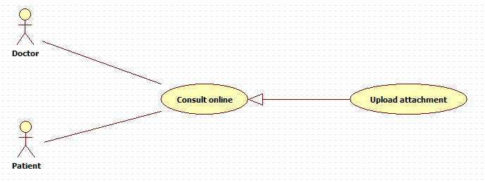

Figure 13 <Doctor>< Patient> Upload Attachment

#### Use Case-7 Specification

|  |  |  |  |  |
| --- | --- | --- | --- | --- |
| **USE CASE - 7 SPECIFICATION** | | | | |
| **Use-case No.** | UC_007 | **Use-case Version** | | **1.0** |
| **Use-case Name** | <Patient><Doctor> Upload Attachment | | | |
| **Author** | SuTNT | | | |
| **Date** | 29/05/2014 | **Priority** | Normal | |
| **Actor:**   * Patient * Doctor   **Summary:** This use case is about Uploading attachment for user when chatting.  **Goal:** User can upload attachment when chatting.  **Triggers:** User clicks on “Gửi tập tin**”** button on chatpage.  **Preconditions:**   * User must log in with role “Patient” or “Doctor”. * User is on chat page.   **Post-Conditions:**   * Success: Upload attachment successfully. * Failure: System displays error message. Content of error message will specify in Exception section.   **Main Success Scenario:**   |  |  |  | | --- | --- | --- | | Step | Actor Action | System Response | | 1 | User clicks on “Đính kèm” button on page. | Show “Open” window. This window will help user access to the file that user want to attach. | | 2 | User chooses the file and clicks “Open” button. [Alternative 1] | Send file to store in system.  If attached file is image, show it into chat content. Otherwise, give a link to the doctor or patient for downloading. |   **Alternative Scenario:**   |  |  |  | | --- | --- | --- | | No | Actor Action | System Response | | 1 | User clicks on “Cancel” button | Back to chat page and no file is attached |   **Exception:**   |  |  |  | | --- | --- | --- | | No | Actor Action | System Response | | 1 | File size is larger than specified file. | Display message “Tập tin lớn hơn quy định. Vui lòng chọn tập tin phù hợp với yêu cầu” |   **Relationship:** Consult Online  **Business Rules:**   * Image file can be showed directly on chat window. | | | | |

Table 7 <Doctor>< Patient> Upload Attachment

#### Functional Requirement 8 – View Consulting History

#### Use Case-8 Diagram



Figure 14< Patient> View consult history

#### Case-8 Specification

|  |  |  |  |  |
| --- | --- | --- | --- | --- |
| **USE CASE - 8 SPECIFICATION** | | | | |
| **Use-case No.** | UC_008 | **Use-case Version** | | **1.0** |
| **Use-case Name** | <Patient> View Consulting History | | | |
| **Author** | DanhTC | | | |
| **Date** | 29/05/2014 | **Priority** | Normal | |
| **Actor:**   * Patient   **Summary:** This use case is about Showing consulting history.  **Goal:** User can view consulting history.  **Triggers:** User clicks on “Lịch sử tư vấn**”** link.  **Preconditions:**   * User must log in with role “Patient”.   **Post-Conditions:**   * Success: Consulting history is show successfully. * Failure: System displays error message. Content of error message will specify in Exception section.   **Main Success Scenario:**   |  |  |  | | --- | --- | --- | | Step | Actor Action | System Response | | 1 | User clicks on “Lịch sử tư vấn” link. | * Redirect to “Lịch sử tư vấn” page. * System will show a list of conversation as a grid and order by consulted date. | | 2 | User chooses the conversation and clicks on “Xem lược sử” button. | * Open “Lược sử” pop-up page. [Alternative 1] * Display conversation between doctor and patient from consulted date. |   **Alternative Scenario:**   |  |  |  | | --- | --- | --- | | No | Actor Action | System Response | | 1 | User clicks on “Bỏ qua” button | Close “Lược sử” pop-up page. |   **Exception:**   |  |  |  | | --- | --- | --- | | No | Actor Action | System Response | | 1 | Internet connection has problem | Display message “Kết nối mạng bị lỗi. Xin thử lại” |   **Relationship:** Consult Online  **Business Rules:** N/A | | | | |

Table 8 < Patient> View consult history

#### Functional Requirement 9 – View Doctor Online

#### Use Case-9 Diagram



Figure < Patient> View doctor online

#### Use Case-9 Specification

|  |  |  |  |  |
| --- | --- | --- | --- | --- |
| **USE CASE - 9 SPECIFICATION** | | | | |
| **Use-case No.** | UC_009 | **Use-case Version** | | **1.0** |
| **Use-case Name** | <Patient> View doctor online | | | |
| **Author** | SuTNT | | | |
| **Date** | 29/05/2014 | **Priority** | Normal | |
| **Actor:**   * Patient   **Summary:** This use case is about viewing doctor online for a patient.  **Goal:** Patient can view doctor online.  **Triggers:** Patient goes to “Tư vấn trực tuyến” page and online doctor will have online icon.  **Preconditions:**   * Page load successfully. * User must log in with role “Patient”.   **Post-Conditions:**   * Success: Online doctors appear in the list with online icon. * Failure: System displays error message. Content of error message will specify in Exception section.   **Main Success Scenario:**   |  |  |  | | --- | --- | --- | | Step | Actor Action | System Response | | 1 | User clicks on “Tư vấn trực tuyến” link. | * Show the list of doctor and doctors will be grouped by specialty. * Online doctor will have online icon. |   **Alternative Scenario:** N/A  **Exception:**   |  |  |  | | --- | --- | --- | | No | Actor Action | System Response | | 3 | Internet connection has problem | Display message “Kết nối mạng bị lỗi. Xin thử lại” |   **Relationship:** Consult Online  **Business Rules:**   * When doctor go to “Tư Vấn Trực Tuyến”. Doctor status is online and update instantly for patients. * When doctor close page “Tư Vấn Trực Tuyến”. Doctor status become offline and update instantly for patients. | | | | |

Table < Patient> View doctor online

#### Functional Requirement 10 – Update medical profile

#### Use Case-10 Diagram

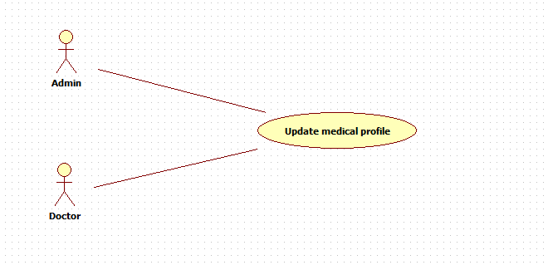

Figure <Doctor>< Admin> Update medical profile

#### Case-10 Specification

|  |  |  |  |  |
| --- | --- | --- | --- | --- |
| **USE CASE - 10 SPECIFICATION** | | | | |
| **Use-case No.** | UC_010 | **Use-case Version** | | **1.0** |
| **Use-case Name** | <Doctor><Admin> Update medical profile | | | |
| **Author** | DanhTC | | | |
| **Date** | 30/05/2014 | **Priority** | Normal | |
| **Actor:**   * Doctor * Admin   **Summary:** This use case is doctor update medical profile.  **Goal:** Doctor can update medical profile.  **Triggers:** Doctor clicks on “Cập nhật**”** button on “DoctorMedicalProfile”page.  **Preconditions:** User must be logged - in as “Doctor”.  **Post-Conditions:**   * Success: A medical profile is updated in the system. * Failure: The doctor is presented with an error message.   **Main Success Scenario:**   |  |  |  | | --- | --- | --- | | Step | Actor Action | System Response | | 1 | User logged – in as “Doctor” and clicks on “Cập nhật” button on “DoctorMedicalProfile” page. | Display “UpdateMedicalProfile” page with patient’s fields has been added to doctor can edit and update. | | 2 | Input suitable fields want to update and click on “Cập nhật” button. | * Validate input data. * Display message: “Cập nhật thành công”. |   **Alternative Scenario:**   |  |  |  | | --- | --- | --- | | No | Actor Action | System Response | | 1 | Exit criteria from main flow: 4 validate input data fails | Exit criteria from main flow: 4 validate input data fails. |   **Exception:**   |  |  |  | | --- | --- | --- | | No | Actor Action | System Response | | 3 | Internet connection has problem | Display message “Kết nối mạng bị lỗi. Xin thử lại” |   **Relationship:** N/A  **Business Rules:** N/A | | | | |

Table 10<Doctor>< Admin> Update medical profile

#### Functional Requirement 11 – Create Doctor

#### Use Case-11 Diagram



Figure <Admin> Create doctor

#### Use Case-11 Specification

|  |  |  |  |  |
| --- | --- | --- | --- | --- |
| **USE CASE - 11 SPECIFICATION** | | | | |
| **Use-case No.** | UC_011 | **Use-case Version** | | **1.0** |
| **Use-case Name** | <Admin> Create Doctor | | | |
| **Author** | SuTNT | | | |
| **Date** | 29/05/2014 | **Priority** | Normal | |
| **Actor:**   * Admin   **Summary:** This use case allows admin can create new doctor.  **Goal:** Help admin to create new doctor account.  **Trigger:** Click on “Tạo Mới” button on “AdminDoctor” page.  **Precondition:**   * Page is loaded successfully. * Users have already logged in with role “admin”.   **Post-condition:**   * Success: New doctor is inserted into database. * Failure: System displays error message. Content of error message will specify in Exception section.   **Main Success Scenario:**   |  |  |  | | --- | --- | --- | | Step | Actor Action | System Response | | 1 | User clicks on “Tạo Mới” button on “AdminDoctor” page. | * Open “Tạo mới bác sĩ” pop-up page. * Display input fields. | | 2 | User fills all mandatory fields. |  | |  | User clicks on “Lưu” button. [Alternative 1] | * Validate input data. * Redirect to “AdminDoctor” page. |   **Alternative Scenario:**   |  |  |  | | --- | --- | --- | | No | Actor Action | System Response | | 1 | User clicks on “Bỏ Qua” button | Close “Tạo Mới” pop-up page. |   **Exception:**   |  |  |  | | --- | --- | --- | | No | Actor Action | System Respons | | 1 | Internet connection has problem | Display message “Kết nối mạng bị lỗi. Xin thử lại” |   **Relationship:** Manage Doctor  **Business Rules:**   * Created account is active and has role “Doctor”. | | | | |

Table <Admin> Create doctor

#### Functional Requirement 12 – Edit Doctor

#### Use Case-12 Diagram



Figure <Admin> Edit doctor

#### Use Case-12 Specification

|  |  |  |  |  |
| --- | --- | --- | --- | --- |
| **USE CASE - 13 SPECIFICATION** | | | | |
| **Use-case No.** | UC_012 | **Use-case Version** | | **1.0** |
| **Use-case Name** | <Admin> Edit Doctor | | | |
| **Author** | DanhTC | | | |
| **Date** | 29/05/2014 | **Priority** | Normal | |
| **Actor:**   * Admin   **Summary:** This use case allows admin can edit doctor information.  **Goal:** Help admin to edit doctor account.  **Trigger:** Click on “Cập Nhật” button on “AdminDoctor” page.  **Precondition:**   * Page is loaded successfully. * Users have already logged in with role “admin”.   **Post-condition:**   * Success: Doctor’s information is updated in database. * Failure: System displays error message. Content of error message will specify in Exception section.   **Main Success Scenario:**   |  |  |  | | --- | --- | --- | | Step | Actor Action | System Response | | 1 | User clicks on “Cập Nhật” button on “AdminDoctor” page. | * Open “Cập nhật” pop-up page. * Display input fields. | | 2 | User fills all mandatory fields. |  | | 3 | User clicks on “Lưu” button. [Alternative 1] | * Validate input data. * Redirect to “AdminDoctor” page. |   **Alternative Scenario:**   |  |  |  | | --- | --- | --- | | No | Actor Action | System Response | | 1 | User clicks on “Bỏ Qua” button | Close “Cập nhật” pop-up page. |   **Exception:**   |  |  |  | | --- | --- | --- | | No | Actor Action | System Reponse | | 1 | Internet connection has problem | Display message “Kết nối mạng bị lỗi. Xin thử lại” | | 2 | When session timeout. | Display an informed message “Thời gian thực thi của bạn đã hết. Vui lòng đăng nhập lại”. | | 3 | Fail to update in database | Display message “Có lỗi xảy ra. Vui lòng thử lại”. |   **Relationship:** Manage Doctor  **Business Rules:**   * Username is forbidden. | | | | |

Table <Admin> Edit doctor

#### Functional Requirement 13 – Search Doctor

#### Use Case-13 Diagram



Figure <Admin> Search doctor

#### Use Case-13 Specification

|  |  |  |  |  |
| --- | --- | --- | --- | --- |
| **USE CASE - 13 SPECIFICATION** | | | | |
| **Use-case No.** | UC_013 | **Use-case Version** | | **1.0** |
| **Use-case Name** | <Admin> Search Doctor | | | |
| **Author** | SuTNT | | | |
| **Date** | 29/05/2014 | **Priority** | Normal | |
| **Actor:**   * Admin   **Summary:** This use case allows admin can search doctor.  **Goal:** Help admin to search doctor account.  **Trigger:**   * In search screen, user inputs email/full name of doctor then they search all doctor with relative email/full name which they inputted. The searching results will show a list of doctor which follow doctor account’ created date. * User input to a blank text-box then clicks on “Tìm Kiếm” button.   **Precondition:**   * Page is loaded successfully. * Users have already logged in with role “admin”.   **Post-condition:**   * Success: Show search results which include a list of doctor. * Failure: System displays error message. Content of error message will specify in Exception section.   **Main Success Scenario:**   |  |  |  | | --- | --- | --- | | Step | Actor Action | System Response | | 1 | User inputs the doctor’s email/full name into text-box. |  | | 2 | User clicks on “Tìm Kiếm” button. | * System will show a list of doctor as a grid and order by doctor account’s created date. [Alternative 1] * A doctor will show in a line as a record with these information: * First column is email. * Second column is full name. * Third column is status. * Fourth column is created date. * Fifth column has 2 buttons: “Cập Nhật” and “Vô Hiệu/Kích Hoạt”. |   **Alternative Scenario:**   |  |  |  | | --- | --- | --- | | No | Actor Action | System Response | | 1 | No record found. | Display no record. |   **Exception:**   |  |  |  | | --- | --- | --- | | No | Actor Action | System Response | | 3 | Internet connection has problem | Display message “Kết nối mạng bị lỗi. Xin thử lại” |   **Relationship:** Manage Doctor  **Business Rules:**   * Search by doctor’s email/full name, using containing text search. | | | | |

Table <Admin> Search doctor

#### Functional Requirement 14 – Deactivate Doctor

#### Use Case-14 Diagram



Figure 20 <Admin> Deactivate Doctor

#### Use Case-14 Specification

|  |  |  |  |  |
| --- | --- | --- | --- | --- |
| **USE CASE - 14 SPECIFICATION** | | | | |
| **Use-case No.** | UC_014 | **Use-case Version** | | **1.0** |
| **Use-case Name** | <Admin> Deactivate Doctor | | | |
| **Author** | DanhTC | | | |
| **Date** | 29/05/2014 | **Priority** | Normal | |
| **Actor:** Admin  **Summary:** This use case is about deactivating doctor account.  **Goal:** Help admin to deactivating a doctor account.  **Trigger:** Click on “Vô Hiệu” button corresponding with each doctor account in the doctor account list of “AdminDoctor” page.  **Precondition:**   * “AdminDoctor” page is loaded successfully. * Users have already logged in with role “admin”.   **Post-condition:**   * Success: The doctor account is deactivated and can’t log in. * Failure: System displays error message. Content of error message will specify in Exception section.   **Main Success Scenario:**   |  |  |  | | --- | --- | --- | | Step | Actor Action | System Response | | 1 | Click on “Vô Hiệu” button | * The corresponding doctor account change to “Bị Khóa” status. * “Vô Hiệu” button change to “Kích Hoạt” button. |   **Alternative Scenario:** N/A  **Exception:**   |  |  |  | | --- | --- | --- | | No | Actor Action | System Response | | 1 | Internet connection has problem | Display message “Kết nối mạng bị lỗi. Xin thử lại” | | 2 | When session timeout. | Display an informed message “Thời gian thực thi của bạn đã hết. Vui lòng đăng nhập lại”. |   **Relationship:** Manage Doctor  **Business Rules:**   * Admin can’t activate/deactivate account of themselves or other admins. | | | | |

Table 14 <Admin> Deactivate Doctor

#### Functional Requirement 15 – Activate Doctor

#### Use Case-15 Diagram



Figure <Admin> Activate doctor

#### Use Case-14 Specification

|  |  |  |  |  |
| --- | --- | --- | --- | --- |
| **USE CASE - 14 SPECIFICATION** | | | | |
| **Use-case No.** | UC_015 | **Use-case Version** | | **1.0** |
| **Use-case Name** | <Admin> Activate Doctor | | | |
| **Author** | SuTNT | | | |
| **Date** | 29/05/2014 | **Priority** | Normal | |
| **Actor:** Admin  **Summary:** This use case is about activating doctor account.  **Goal:** Help admin to activating a doctor account.  **Trigger:** Click on “Kích Hoạt” button corresponding with each doctor account in the doctor account list of “AdminDoctor” page.  **Precondition:**   * “AdminDoctor” page is loaded successfully. * Users have already logged in with role “admin”.   **Post-condition:**   * Success: The doctor account is activated and can log in. * Failure: System displays error message. Content of error message will specify in Exception section.   **Main Success Scenario:**   |  |  |  | | --- | --- | --- | | Step | Actor Action | System Response | | 1 | Click on “Kích Hoạt” button | * The corresponding doctor account change to “Hoạt Động” status. * “Kích Hoạt” button change to “Vô Hiệu” button. |   **Alternative Scenario:** N/A  **Exception:**   |  |  |  | | --- | --- | --- | | No | Actor Action | System Response | | 1 | Internet connection has problem | Display message “Kết nối mạng bị lỗi. Xin thử lại” |   **Relationship:** Manage Doctor  **Business Rules:**   * Admin can’t activate/deactivate account of themselves or other admins. | | | | |

Table <Admin> Activate doctor

#### Functional Requirement 16 – Create Patient

#### Use Case-16 Diagram

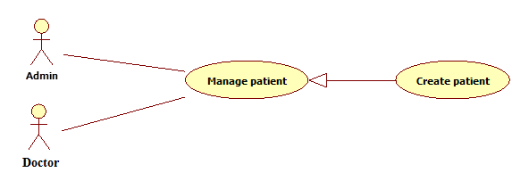

Figure 22 <Admin><Doctor> Create patient

#### Case-16 Specification

|  |  |  |  |  |
| --- | --- | --- | --- | --- |
| **USE CASE - 13 SPECIFICATION** | | | | |
| **Use-case No.** | UC_013 | **Use-case Version** | | **1.0** |
| **Use-case Name** | <Admin><Doctor> Create Patient | | | |
| **Author** | DanhTC | | | |
| **Date** | 29/05/2014 | **Priority** | Normal | |
| **Actor:**   * Admin * Doctor   **Summary:** This use case allows admin/doctor can create new patient.  **Goal:** Help admin/doctor to create new patient account.  **Trigger:** Click on “Tạo Mới” button on “Quản lý bệnh nhân” navigation.  **Precondition:**   * Page is loaded successfully. * Users have already logged in with role “admin” or “doctor”.   **Post-condition:**   * Success: New patient is inserted into database. * Failure: System displays error message. Content of error message will specify in Exception section.   **Main Success Scenario:**   |  |  |  | | --- | --- | --- | | Step | Actor Action | System Response | | 1 | User clicks on “Tạo Mới” button on “Quản lý bệnh nhân” navigation. | * Open “Tạo mới bệnh nhân” pop-up page. * Display input fields. | | 2 | User fills all mandatory fields. |  | | 3 | User clicks on “Lưu” button. [Alternative 1] | * Validate input data. * Redirect to “Index” page. |   **Alternative Scenario:**   |  |  |  | | --- | --- | --- | | No | Actor Action | System Response | | 1 | User clicks on “Bỏ Qua” button | Close “Tạo Mới” pop-up page. |   **Exception:**   |  |  |  | | --- | --- | --- | | No | Actor Action | System Response | | 1 | Internet connection has problem | Display message “Kết nối mạng bị lỗi. Xin thử lại” |   **Relationship:** Manage Patient  **Business Rules:**   * Created account is active and has role “Patient”. | | | | |

Table 16 <Admin><Doctor> Create patient

#### Functional Requirement 17 – Edit Patient

#### Use Case-17 Diagram

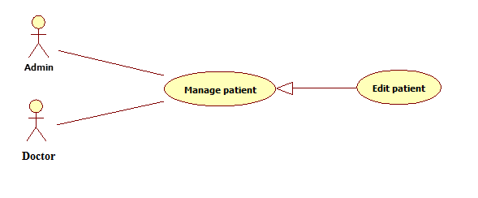

Figure 23 <Admin><Doctor> Edit patient

#### Use Case-17 Specification

|  |  |  |  |  |
| --- | --- | --- | --- | --- |
| **USE CASE - 13 SPECIFICATION** | | | | |
| **Use-case No.** | UC_017 | **Use-case Version** | | **1.0** |
| **Use-case Name** | <Admin><Doctor> Edit Patient | | | |
| **Author** | SuTNT | | | |
| **Date** | 29/05/2014 | **Priority** | Normal | |
| **Actor:**   * Admin * Doctor   **Summary:** This use case allows admin/doctor can edit patient information.  **Goal:** Help admin/doctor to edit patient account.  **Trigger:** Click on “Cập Nhật” button on “Quản lý bệnh nhân” navigation.  **Precondition:**   * Page is loaded successfully. * Users have already logged in with role “admin” or “doctor”.   **Post-condition:**   * Success: Patient’s information is updated in database. * Failure: System displays error message. Content of error message will specify in Exception section.   **Main Success Scenario:**   |  |  |  | | --- | --- | --- | | Step | Actor Action | System Response | | 1 | User clicks on “Cập Nhật” button on “Quản lý bệnh nhân” navigation. | * Open “Cập nhật” pop-up page. * Display input fields. | | 2 | User fills all mandatory fields. |  | | 3 | User clicks on “Lưu” button. [Alternative 1] | * Validate input data. * Redirect to “Index” page. |   **Alternative Scenario:**   |  |  |  | | --- | --- | --- | | No | Actor Action | System Response | | 1 | User clicks on “Bỏ Qua” button | Close “Cập nhật” pop-up page. |   **Exception:**   |  |  |  | | --- | --- | --- | | No | Actor Action | System Response | | 1 | Internet connection has problem | Display message “Kết nối mạng bị lỗi. Xin thử lại” |   **Relationship:** Manage Patient  **Business Rules:**   * Email is forbidden. * Password is forbidden. | | | | |

Table 17 <Admin><Doctor> Edit patient

#### Functional Requirement 18 – Search Patient

#### Use Case-18 Diagram

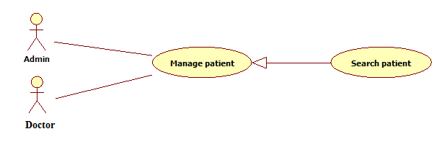

Figure 24 <Admin><Doctor> Search patient

#### Use Case-18 Specification

|  |  |  |  |  |
| --- | --- | --- | --- | --- |
| **USE CASE - 13 SPECIFICATION** | | | | |
| **Use-case No.** | UC_018 | **Use-case Version** | | **1.0** |
| **Use-case Name** | <Admin><Doctor> Search Patient | | | |
| **Author** | DanhTC | | | |
| **Date** | 29/05/2014 | **Priority** | Normal | |
| **Actor:**   * Admin * Doctor   **Summary:** This use case allows admin/doctor can search patient.  **Goal:** Help admin/doctor to search patient account.  **Trigger:**   * In search screen, user inputs email/full name of patient then they search all patient with relative email/full name which they inputted. The searching results will show a list of patient which follow patient account’ created date. * User input to a blank text-box then clicks on “Tìm Kiếm” button.   **Precondition:**   * Page is loaded successfully. * Users have already logged in with role “admin” or “doctor”.   **Post-condition:**   * Success: Show search results which include a list of patient. * Failure: System displays error message. Content of error message will specify in Exception section.   **Main Success Scenario:**   |  |  |  | | --- | --- | --- | | Step | Actor Action | System Response | | 1 | User inputs the patient’s email/full name into text-box. |  | | 2 | User clicks on “Tìm Kiếm” button. | * System will show a list of patient as a grid and order by patient account’s created date. [Alternative 1] * A patient will show in a line as a record with these information: * First column is email. * Second column is full name. * Third column is status. * Fourth column is created date. * Fifth column has 2 buttons: “Cập Nhật” and “Vô Hiệu/Kích Hoạt”. |   **Alternative Scenario:**   |  |  |  | | --- | --- | --- | | No | Actor Action | System Response | | 1 | No record found. | Display no record. |   **Exception:**   |  |  |  | | --- | --- | --- | | No | Actor Action | System Response | | 1 | Internet connection has problem | Display message “Kết nối mạng bị lỗi. Xin thử lại” |   **Relationship:** Manage Patient  **Business Rules:**   * Search by patient’s email/full name, using containing text search. | | | | |

Table 18 <Admin><Doctor> Search patient

#### Functional Requirement 19 – Deactivate Patient

#### Use Case-19 Diagram



Figure <Admin> Deactivate patient

#### Use Case-19 Specification

|  |  |  |  |  |
| --- | --- | --- | --- | --- |
| **USE CASE - 14 SPECIFICATION** | | | | |
| **Use-case No.** | UC_014 | **Use-case Version** | | **1.0** |
| **Use-case Name** | <Admin> Deactivate Patient | | | |
| **Author** | SuTNT | | | |
| **Date** | 29/05/2014 | **Priority** | Normal | |
| **Actor:**   * Admin   **Summary:** This use case is about deactivating patient account.  **Goal:** Help admin to deactivating a patient account.  **Trigger:** Click on “Vô Hiệu” button corresponding with each patient account in the patient account list of “Quản lý bệnh nhân” navigation.  **Precondition:**   * “Index” page is loaded successfully. * Users have already logged in with role “admin”.   **Post-condition:**   * Success: The patient account is deactivated and can’t log in. * Failure: System displays error message. Content of error message will specify in Exception section.   **Main Success Scenario:**   |  |  |  | | --- | --- | --- | | Step | Actor Action | System Response | | 1 | Click on “Vô Hiệu” button | * The corresponding patient account change to “Bị Khóa” status. * “Vô Hiệu” button change to “Kích Hoạt” button. |   **Alternative Scenario:** N/A  **Exception:**   |  |  |  | | --- | --- | --- | | No | Actor Action | System Response | | 1 | Internet connection has problem | Display message “Kết nối mạng bị lỗi. Xin thử lại” | | 2 | When session timeout. | Display an informed message “Thời gian thực thi của bạn đã hết. Vui lòng đăng nhập lại”. |   **Relationship:** Manage Patient  **Business Rules:**   * Admin can’t activate/deactivate account of themselves or other admins. | | | | |

Table <Admin> Deactivate patient

#### Functional Requirement 20 – Activate Patient

#### Use Case-20 Diagram



Figure <Admin> Activate patient

#### Use Case-20 Specification

|  |  |  |  |  |
| --- | --- | --- | --- | --- |
| **USE CASE - 14 SPECIFICATION** | | | | |
| **Use-case No.** | UC_20 | **Use-case Version** | | **1.0** |
| **Use-case Name** | <Admin> Activate Patient | | | |
| **Author** | DanhTC | | | |
| **Date** | 29/05/2014 | **Priority** | Normal | |
| **Actor:**   * Admin   **Summary:** This use case is about activating patient account.  **Goal:** Help admin to activating a patient account.  **Trigger:** Click on “Kích Hoạt” button corresponding with each patient account in the patient account list of “Quản lý bệnh nhân” navigation.  **Precondition:**   * “Index” page is loaded successfully. * Users have already logged in with role “admin”.   **Post-condition:**   * Success: The patient account is activated and can log in. * Failure: System displays error message. Content of error message will specify in Exception section.   **Main Success Scenario:**   |  |  |  | | --- | --- | --- | | Step | Actor Action | System Response | | 1 | Click on “Kích Hoạt” button | * The corresponding patient account change to “Hoạt Động” status. * “Kích Hoạt” button change to “Vô Hiệu” button. |   **Alternative Scenario:** N/A  **Exception:**   |  |  |  | | --- | --- | --- | | No | Actor Action | System Response | | 1 | Internet connection has problem | Display message “Kết nối mạng bị lỗi. Xin thử lại” | | 2 | When session timeout. | Display an informed message “Thời gian thực thi của bạn đã hết. Vui lòng đăng nhập lại”. |   **Relationship:** Manage Patient  **Business Rules:**   * Admin can’t activate/deactivate account of themselves or other admins. | | | | |

Table <Admin> Activate patient

#### Functional Requirement 21 – Update Medical Profile Template

#### Use Case-21 Diagram

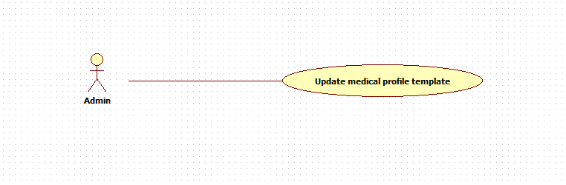

Figure 27 <Admin> Update medical profile template

#### Use Case-21 Specification

|  |  |  |  |  |
| --- | --- | --- | --- | --- |
| **USE CASE - 15 SPECIFICATION** | | | | |
| **Use-case No.** | UC_021 | **Use-case Version** | | **1.0** |
| **Use-case Name** | <Admin> Change Medical Profile Layout | | | |
| **Author** | SuTNT | | | |
| **Date** | 29/05/2014 | **Priority** | Normal | |
| **Actor:** Admin  **Summary:** This use case is about change medical profile layout.  **Goal:** Help admin to change or update medical profile template.  **Trigger:** Click on “Sửa cấu trúc” bệnh nhân on “AdminMedicalProfile” page.  **Precondition:**   * Page is loaded successfully. * Users have already logged in with role “admin”.   **Post-condition:**   * Success: Medical profile template updated. * Failure: System displays error message. Content of error message will specify in Exception section.   **Main Success Scenario:**   |  |  |  | | --- | --- | --- | | Step | Actor Action | System Response | | 1 | Click on “Sửa cấu trúc” button | Show medical profile template is created. | | 2 | Drag in or drag out fields. | Add fields or remove fields. | | 3 | Click on “Cập nhật” button | Display message: “Cập nhật thành công” |   **Alternative Scenario:** N/A  **Exception:**   |  |  |  | | --- | --- | --- | | No | Actor Action | System Response | | 1 | Internet connection has problem | Display message “Kết nối mạng bị lỗi. Xin thử lại” |   **Relationship:** N/A  **Business Rules:** N/A | | | | |

Table 21 <Admin> Update medical profile template

#### Functional Requirement 22 – Change Picture Profile

#### Use Case-22 Diagram



Figure 28<Admin><Doctor><Patient> Change picture profile

#### Use Case-22 Specification

|  |  |  |  |  |
| --- | --- | --- | --- | --- |
| **USE CASE - 22 SPECIFICATION** | | | | |
| **Use-case No.** | UC_022 | **Use-case Version** | | **1.0** |
| **Use-case Name** | <Admin><Doctor><Patient> Change Picture Profile | | | |
| **Author** | DanhTC | | | |
| **Date** | 29/05/2014 | **Priority** | Normal | |
| **Actor:**   * Admin * Patient * Doctor   **Summary:** This use case is about change medical profile picture  **Goal:** Help user to change their medical profile picture  **Trigger:** Click on profile picture in “Index” page and select “Cập nhật ảnh đại diện” to change medical profile picture.  **Precondition:**   * Page is loaded successfully. * Users have already logged in.   **Post-condition:**   * Success: User’s medical profile picture changed. * Failure: System displays error message. Content of error message will specify in Exception section.   **Main Success Scenario:**   |  |  |  | | --- | --- | --- | | Step | Actor Action | System Response | | 1 | Click on “Cập nhật ảnh đại diện” button on index page and select picture. | Display a “change profile” picture box. | | 2 | Select a template profile picture or upload owner’s picture. |  | | 3 | User clicks on “Cập nhật” button. | * Validate input data. * Save to database * Display new profile picture |   **Alternative Scenario:** N/A  **Exception:**   |  |  |  | | --- | --- | --- | | No | Actor Action | System Response | | 1 | Internet connection has problem | Display message “Kết nối mạng bị lỗi. Xin thử lại” | | 2 | When session timeout. | Display an informed message”Thời gian thực thi của bạn đã hết. Vui lòng đăng nhập lại.” | | 3 | File size is larger than permission size. | Display message “Kích cỡ file lớn hơn quy định.” |   **Relationship:** Update Profile  **Business Rules:** N/A | | | | |

Table 22 <Admin><Doctor><Patient> Change picture profile

#### Functional Requirement 23 – Change Password

#### Use Case-23 Diagram

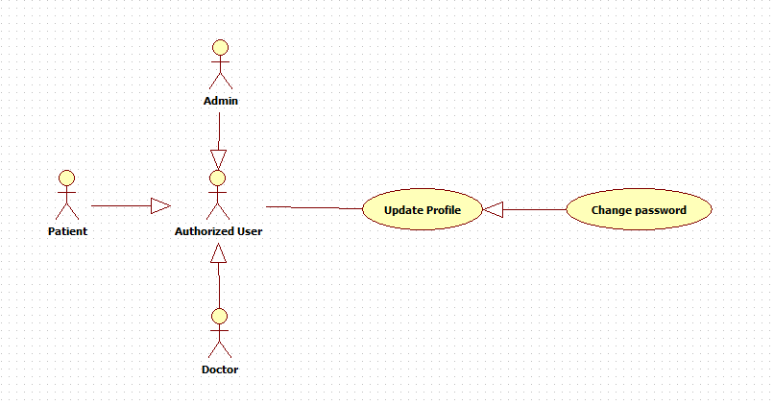

Figure <Admin><Doctor><Patient> Change password

#### Use Case-23 Specification

|  |  |  |  |  |
| --- | --- | --- | --- | --- |
| **USE CASE - 17 SPECIFICATION** | | | | |
| **Use-case No.** | UC_017 | **Use-case Version** | | **1.0** |
| **Use-case Name** | <Admin><Doctor><Patient> Change Password | | | |
| **Author** | DanhTC | | | |
| **Date** | 29/05/2014 | **Priority** | Normal | |
| **Actor:**   * Admin * Patient * Doctor.   **Summary:** This use case is about changing password for user.  **Goal:** User can change their password.  **Trigger:** Click on “Đổi mật khẩu” button on “Index” page to change password.  **Precondition:**   * Page is loaded successfully. * Users have already logged in.   **Post-condition:**   * Success: User’s password changed. * Failure: System displays error message. Content of error message will specify in Exception section.   **Main Success Scenario:**   |  |  |  | | --- | --- | --- | | Step | Actor Action | System Response | | 1 | User clicks on “Đổi mật khẩu” link on profile page. [Alternative1] | Open “Đổi mật khẩu” pop-up page. | | 2 | User fills all mandatory fields. |  | | 3 | User clicks on “Đồng ý” button. [Alternative 1] | * Validate the inputted information * Update user in database. * Show message “Bạn đã thay đổi mật khẩu thành công”. |   **Alternative Scenario:**   |  |  |  | | --- | --- | --- | | No | Actor Action | System Response | | 1 | User clicks on “Bỏ Qua” button. | Close “Đổi mật khẩu” pop-up page. |   **Exception:**   |  |  |  | | --- | --- | --- | | No | Actor Action | System Response | | 1 | Internet connection has problem | Display message “Kết nối mạng bị lỗi. Xin thử lại” | | 2 | When session timeout. | Display an informed message”Thời gian thực thi của bạn đã hết. Vui lòng đăng nhập lại.” |   **Relationship:** Update Profile  **Business Rules:** N/A | | | | |

Table <Admin><Doctor><Patient> Change password

#### Functional Requirement 24 – Define New Medical Profile Template

#### Use Case-24 Diagram

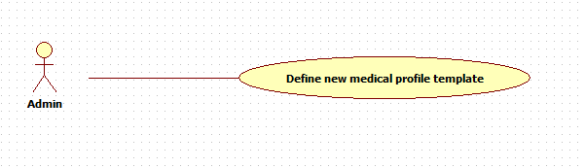

Figure 30 <Admin> Define new medical profile template

#### Use Case-24 Specification

|  |  |  |  |  |
| --- | --- | --- | --- | --- |
| **USE CASE - 17 SPECIFICATION** | | | | |
| **Use-case No.** | UC_024 | **Use-case Version** | | **1.0** |
| **Use-case Name** | <Admin> Define New Medical Profile Template | | | |
| **Author** | DanhTC | | | |
| **Date** | 29/05/2014 | **Priority** | Normal | |
| **Actor:**   * Admin   **Summary:** This use case is about define new medical profile template.  **Goal:** User can define new medical profile template.  **Trigger:** Click on “Thêm mẫu hồ sơ mới” button on “Quản lý mẫu” page to define new medical profile template.  **Precondition:**   * Page is loaded successfully. * Users have already logged in.   **Post-condition:**   * Success: Define new medical profile template. * Failure: System displays error message. Content of error message will specify in Exception section.   **Main Success Scenario:**   |  |  |  | | --- | --- | --- | | Step | Actor Action | System Response | | 1 | Click on “Thêm mẫu hồ sơ mới” button on “Quản lý mẫu” page. [Alternative1] | Open “Thêm mẫu hồ sơ” pop-up page. | | 2 | User fills all mandatory fields. |  | | 3 | User clicks on “Tiếp tục” button. [Alternative 1] | * Validate the inputted information * Insert template in database. * Redirect to “Tạo mẫu hồ sơ” page. | | 4 | User drag fields want to create into “Mẫu hồ sơ”. | Fields will fix follow user drag in. | | 5 | Users click on “Lưu” button. | Display message “Mẫu hồ sơ đã được cập nhật thành công”. |   **Alternative Scenario:**   |  |  |  | | --- | --- | --- | | No | Actor Action | System Response | | 1 | User clicks on “Bỏ Qua” button. | Close “Thêm mẫu hô sơ” pop-up page. |   **Exception:**   |  |  |  | | --- | --- | --- | | No | Actor Action | System Response | | 1 | Internet connection has problem | Display message “Kết nối mạng bị lỗi. Xin thử lại” | | 2 | When session timeout. | Display an informed message”Thời gian thực thi của bạn đã hết. Vui lòng đăng nhập lại.” |   **Relationship:** Define new medical profile  **Business Rules:** N/A | | | | |

Table 24 <Admin> Define new medical profile template

#### Functional Requirement 25 – Logout

#### Use Case-25 Diagram



Figure 31 <Admin><Doctor><Patient> Logout

#### Use Case-25 Specification

|  |  |  |  |  |
| --- | --- | --- | --- | --- |
| **USE CASE - 18 SPECIFICATION** | | | | |
| **Use-case No.** | UC_025 | **Use-case Version** | | **1.0** |
| **Use-case Name** | <Admin><Doctor><Patient> Logout | | | |
| **Author** | SuTNT | | | |
| **Date** | 29/05/2014 | **Priority** | Normal | |
| **Actor:** Admin, patient, doctor  **Summary:** Log out system  **Goal:** Help user to log out their account.  **Triggers:** Click on “Đăng xuất” to log out  **Preconditions:**   * Page is loaded successfully. * Users have already logged in.   **Post-Conditions:**   * Success: users log out successfully. * Failure: System displays error message. Content of error message will specify in Exception section.   **Main Success Scenario:**   |  |  |  | | --- | --- | --- | | Step | Actor Action | System Response | | 1 | User clicks on “Đăng xuất” link on main page. | Logout user, redirect to Home page, logout successfully. |   **Alternative Scenario:**   |  |  |  | | --- | --- | --- | | No | Actor Action | System Response | | 1 | User clicks on “Không” button | Close confirm box. |   **Exception:**   |  |  |  | | --- | --- | --- | | No | Actor Action | System Response | | 1 | Internet connection has problem | Display message “Kết nối mạng bị lỗi. Xin thử lại” |   **Relationship:** Login  **Business Rules:** N/A | | | | |

Table 25 <Admin><Doctor><Patient> Logout